**Problem Statement:**

You work for XYZ Corporation and based on the expansion requirements of your

corporation you have been asked to create and set up a distinct Amazon VPC for

the production and development team. You are expected to perform the following

tasks for the respective VPCs.

**Production Network:**

1. Design and build a 4-tier architecture.

2. Create 5 subnets out of which 4 should be private named app1, app2,

dbcache and db and one should be public, named web.

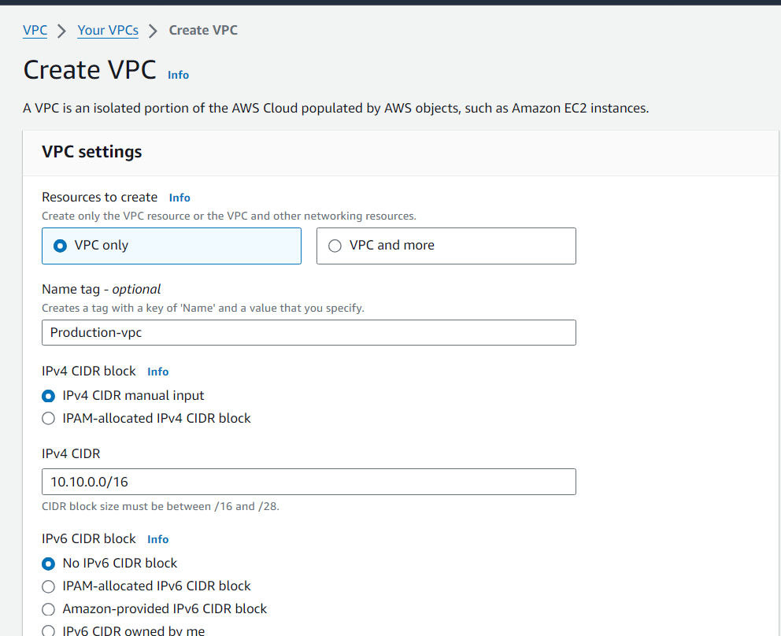

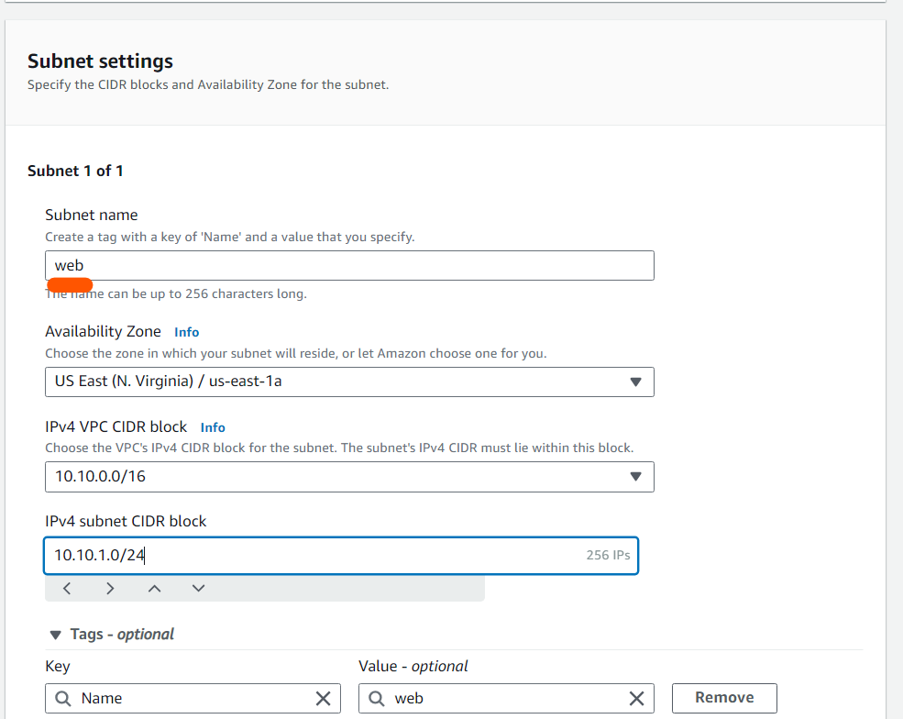

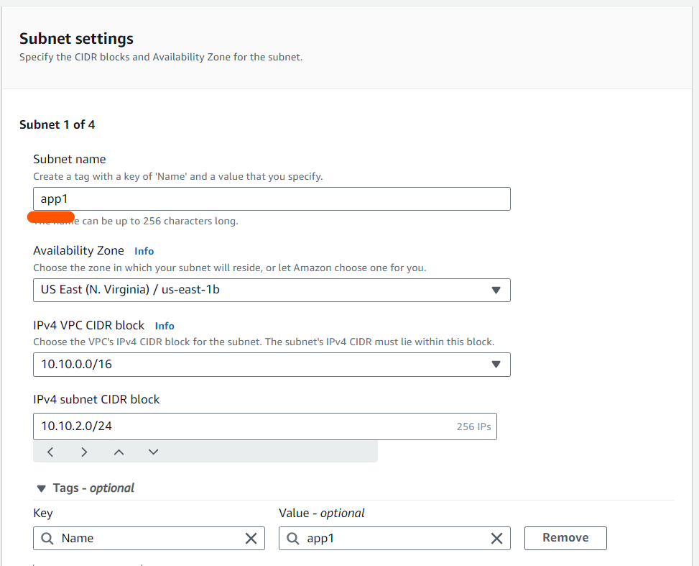

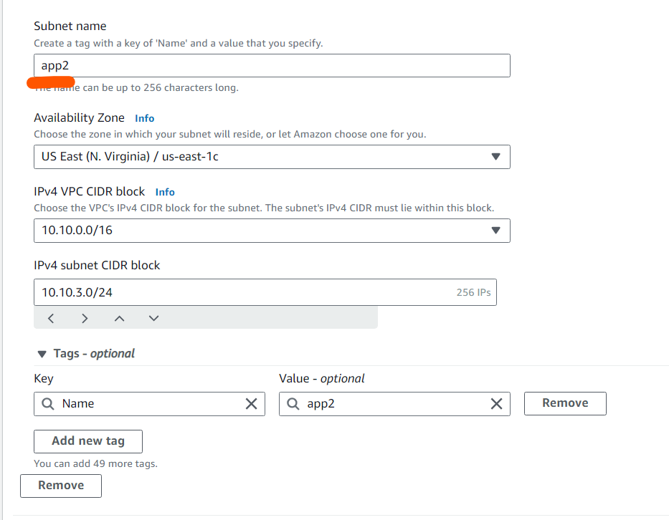

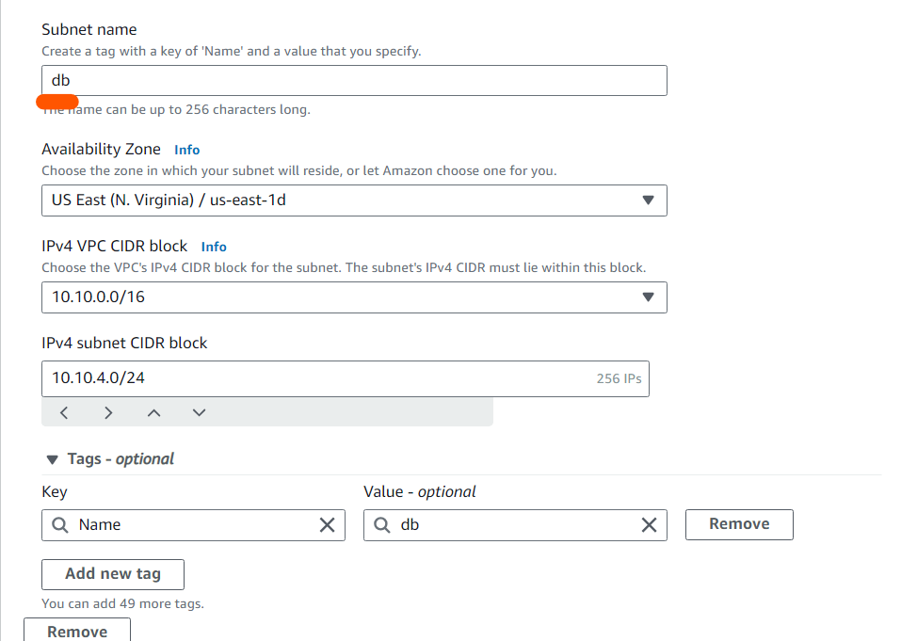

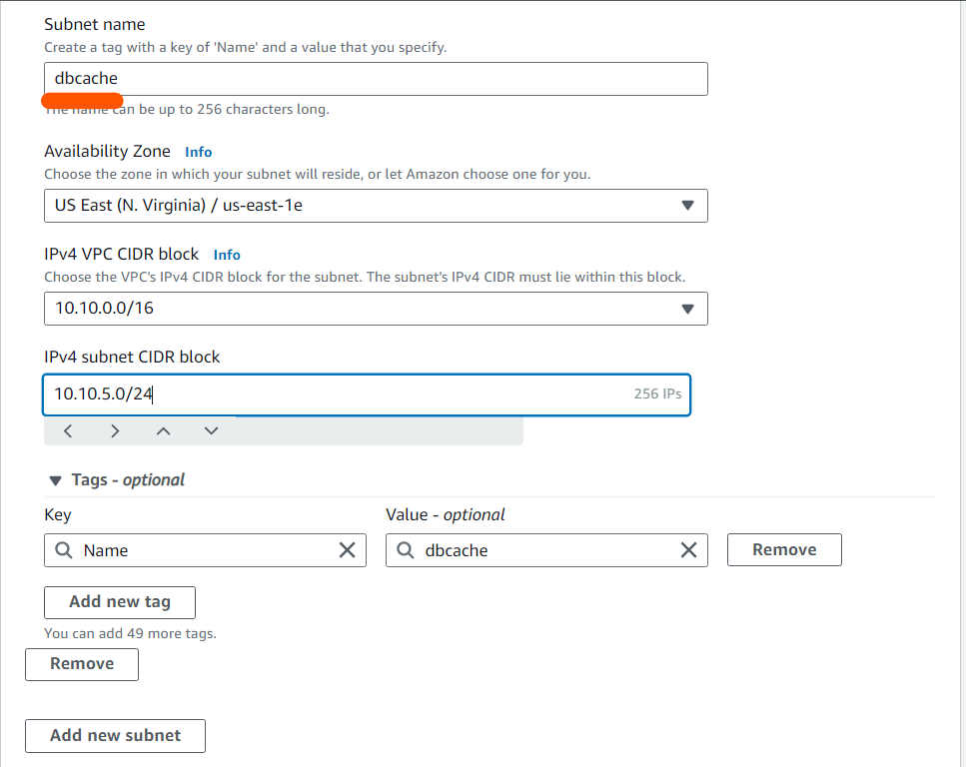

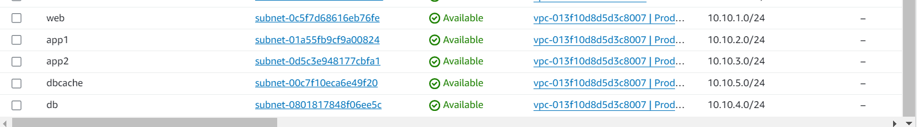

Now make the web subnet as public by creating internet gateway and editing route table

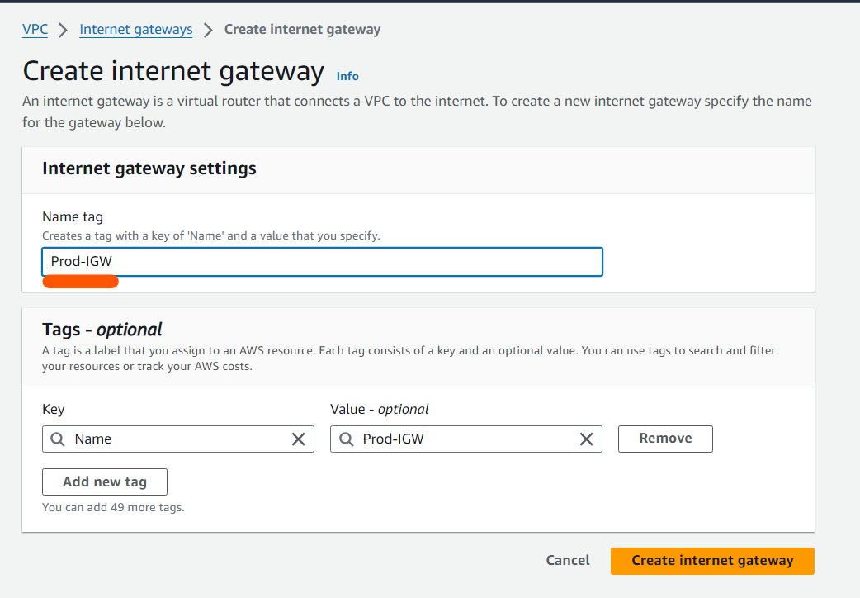

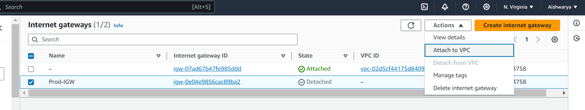

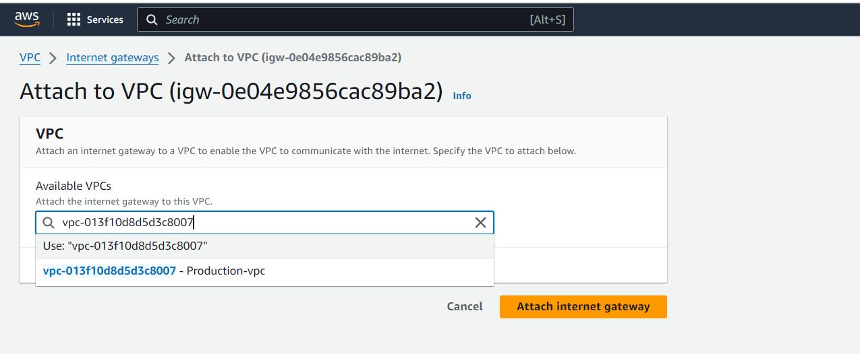

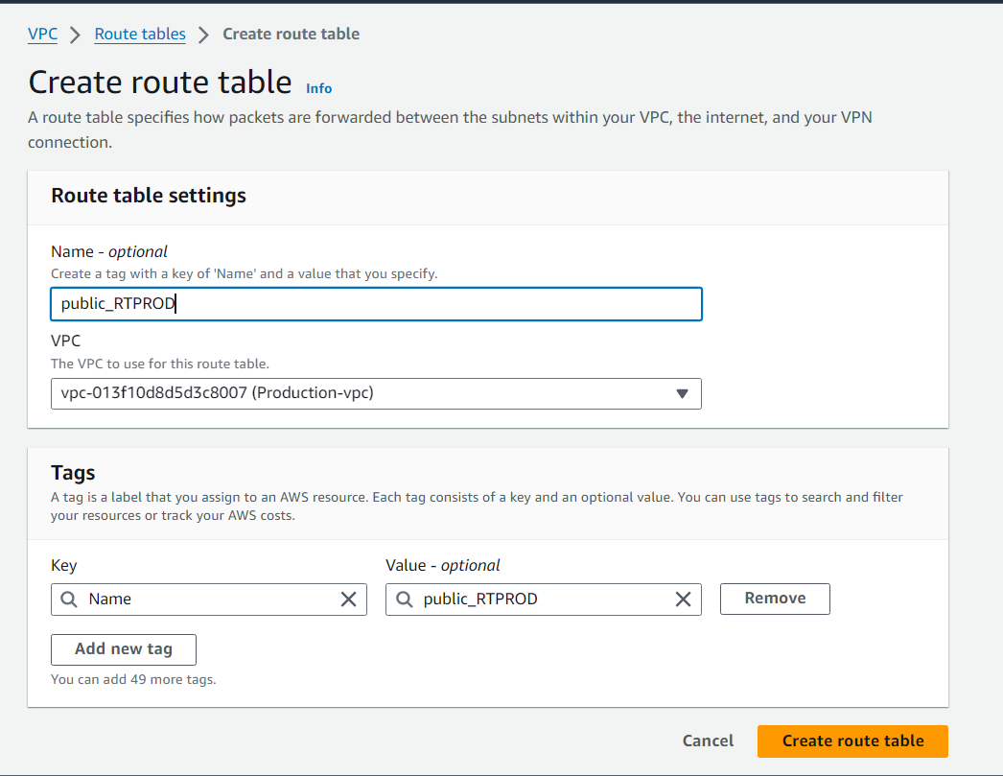

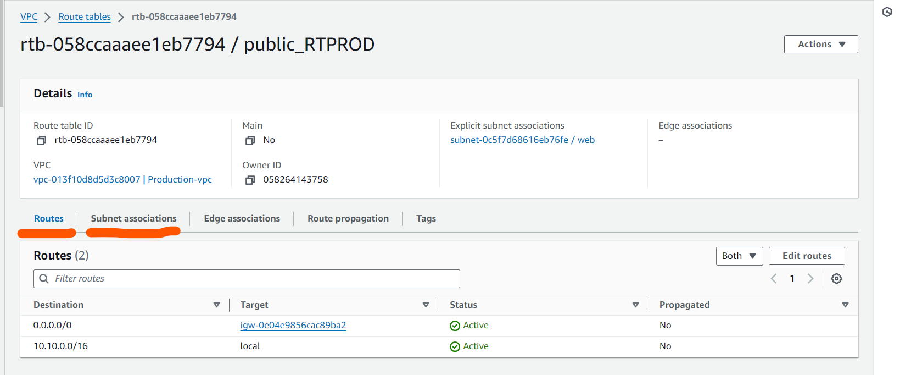

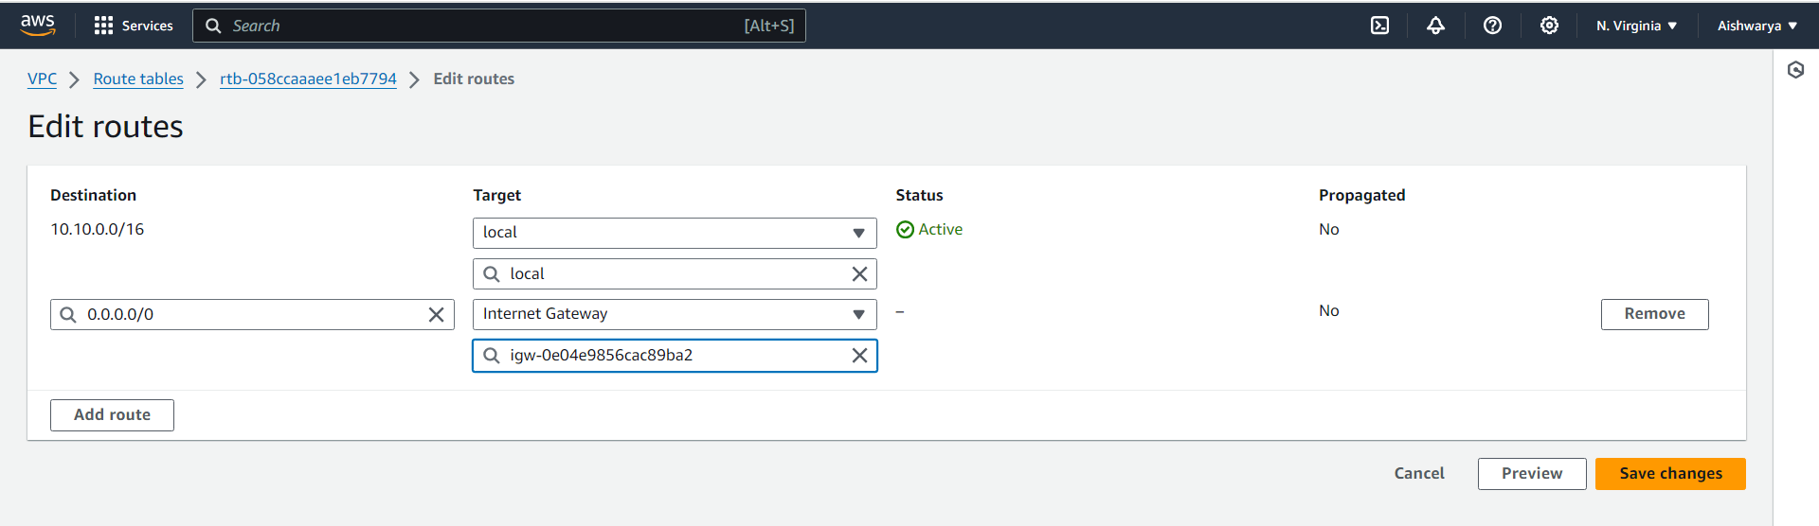

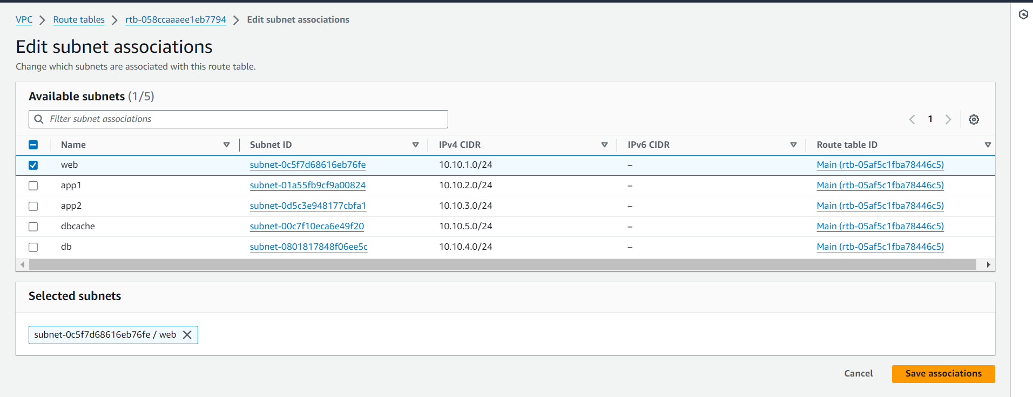

Now create NAT gateway so private subnet can connect to internet through public subnet

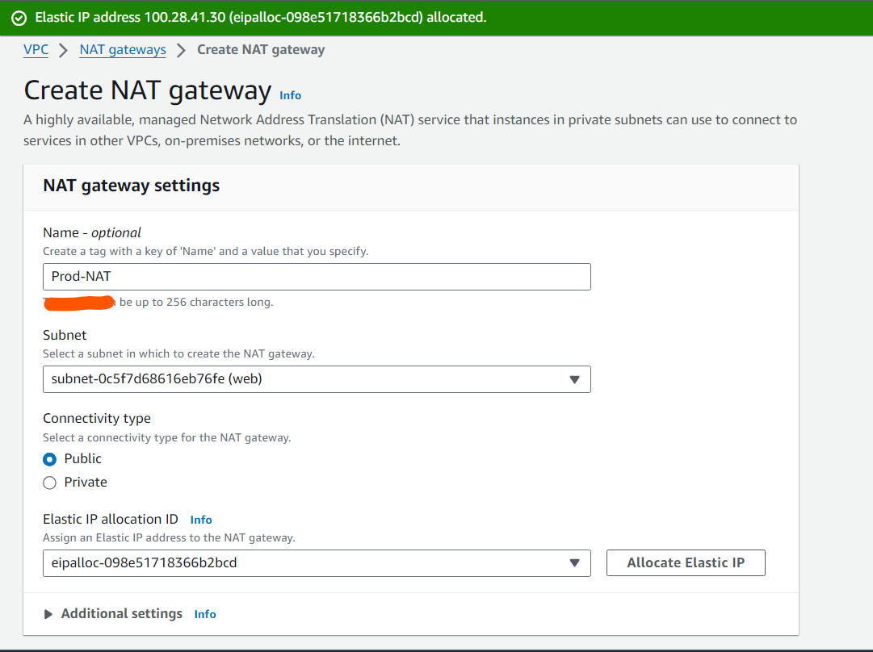

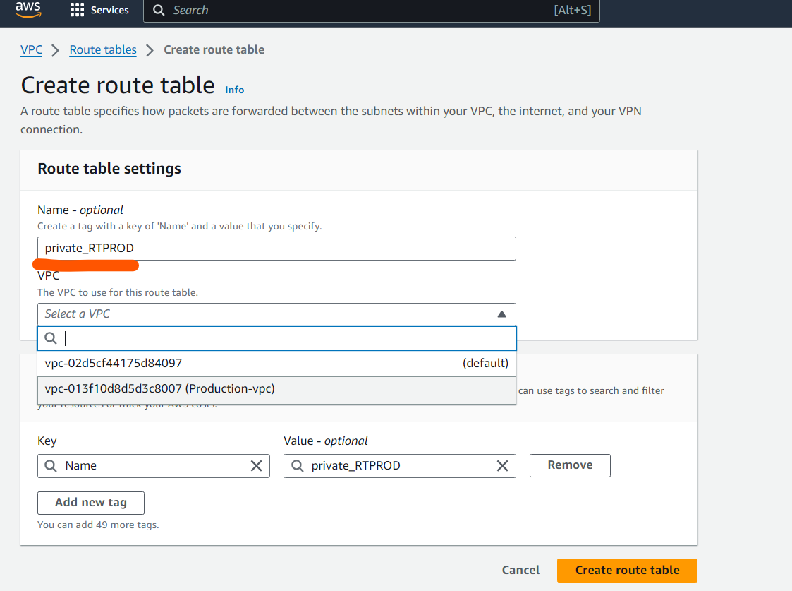

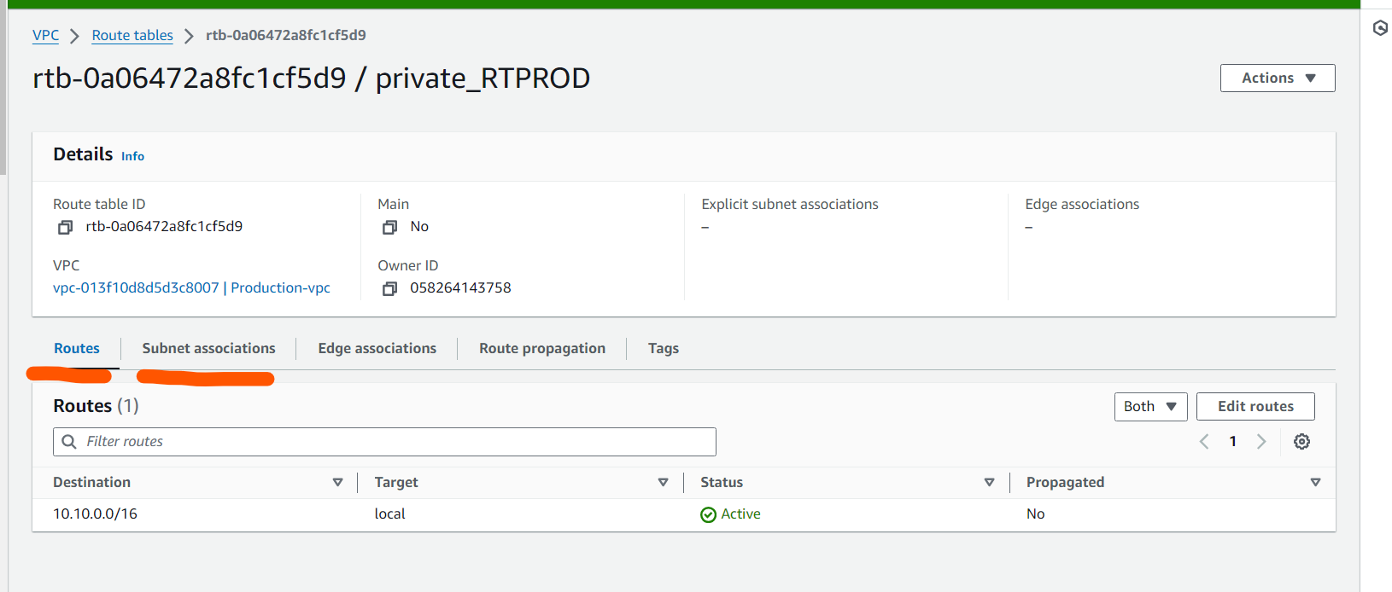

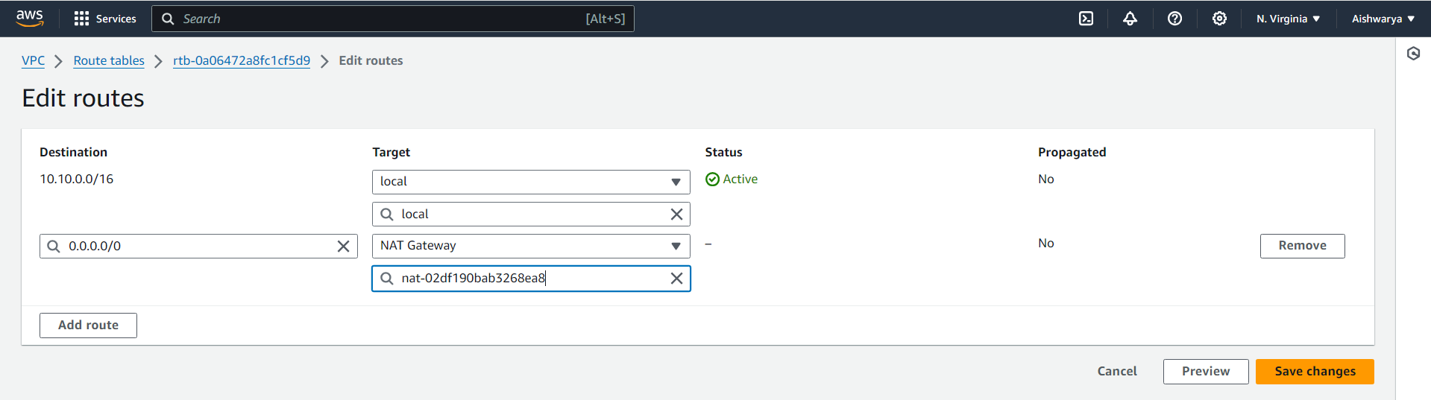

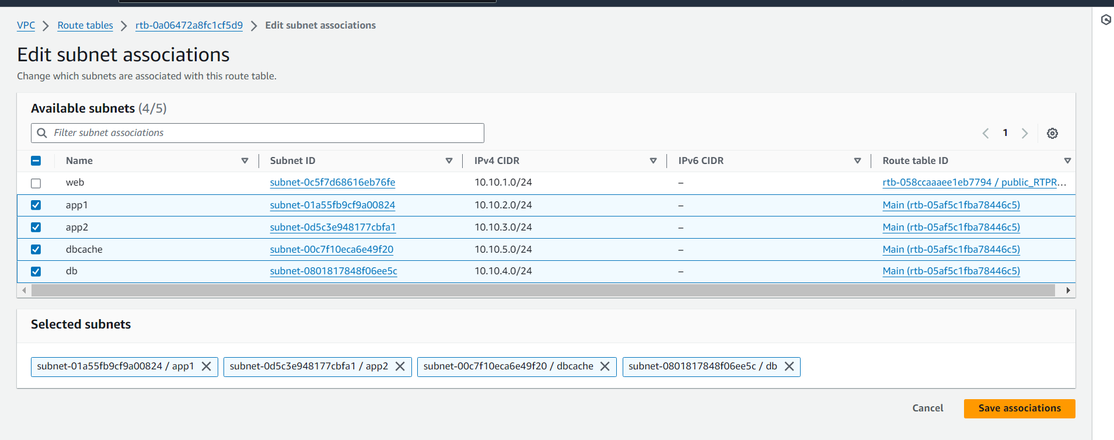

3. Launch instances in all subnets and name them as per the subnet that

they have been launched in.

create instance in web subnet using below network setting

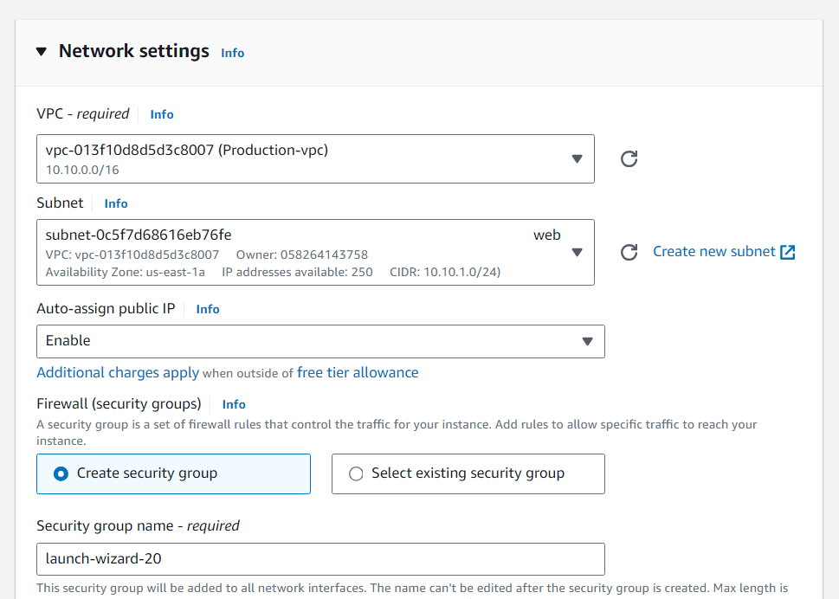

Connect to instance and ping to google as it is in public subnet and have internet connectivity.

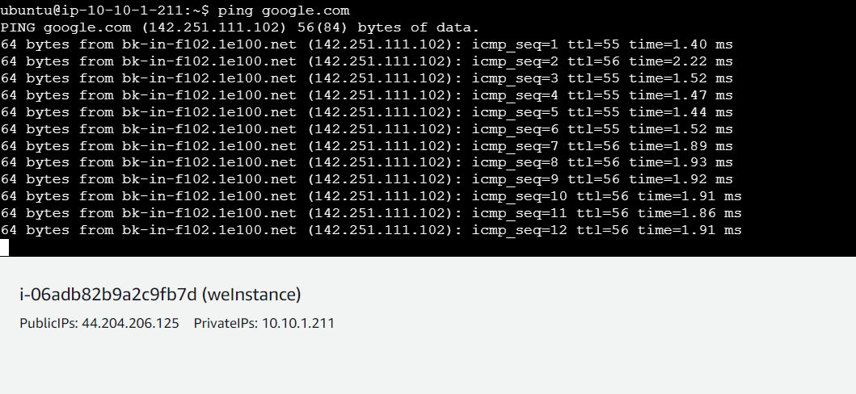

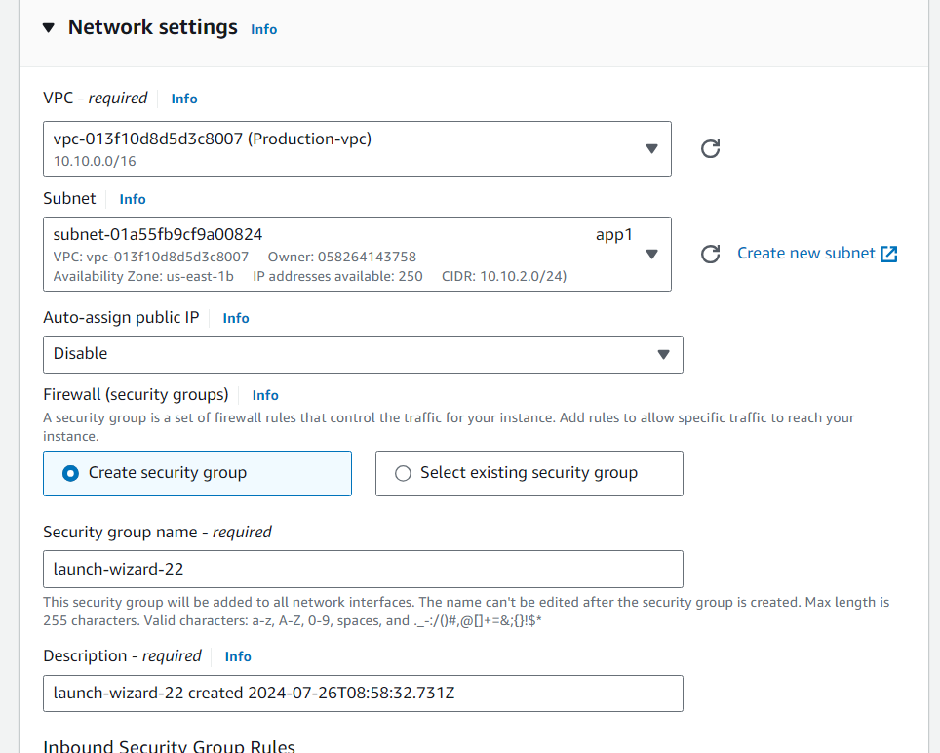

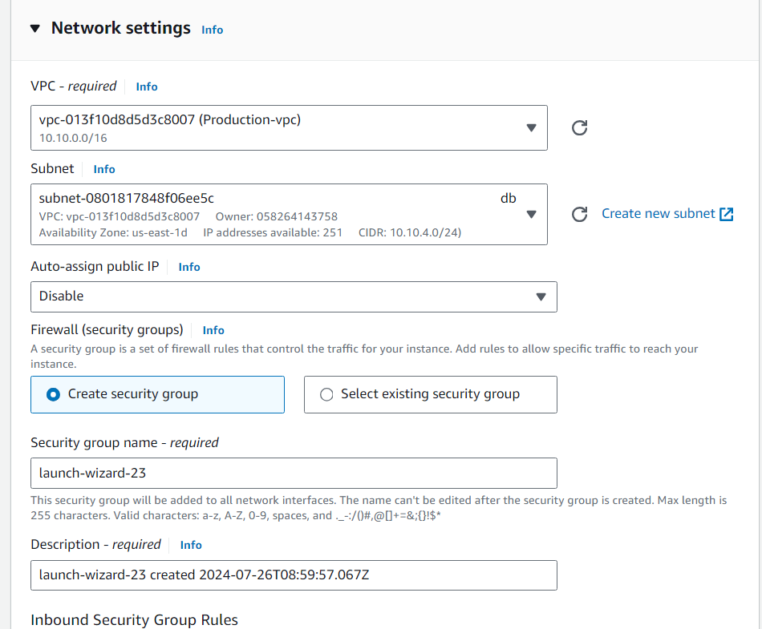

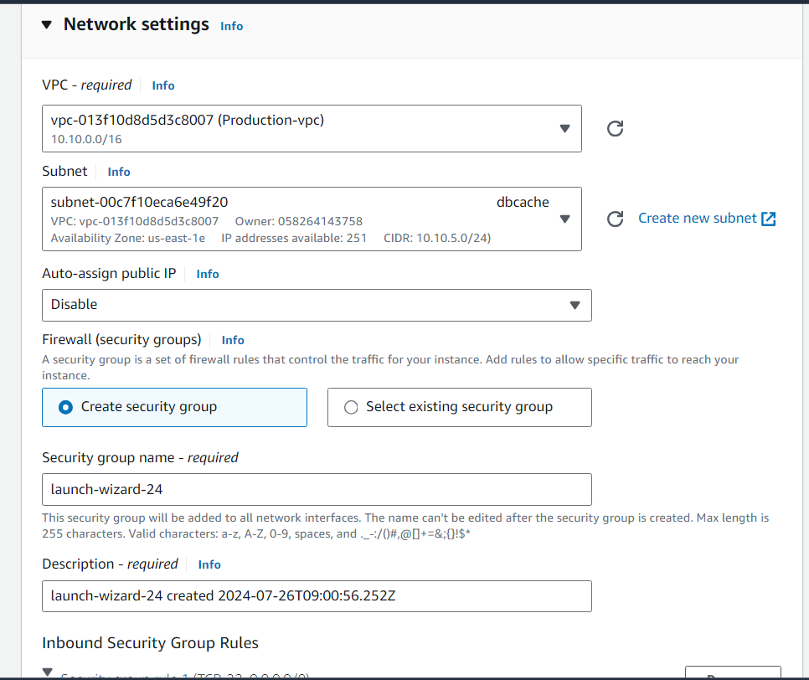

4. Allow dbcache instance and app1 subnet to send internet requests.

5. Manage security groups and NACLs.

Using file zilla copy key to connect to private subnet instances

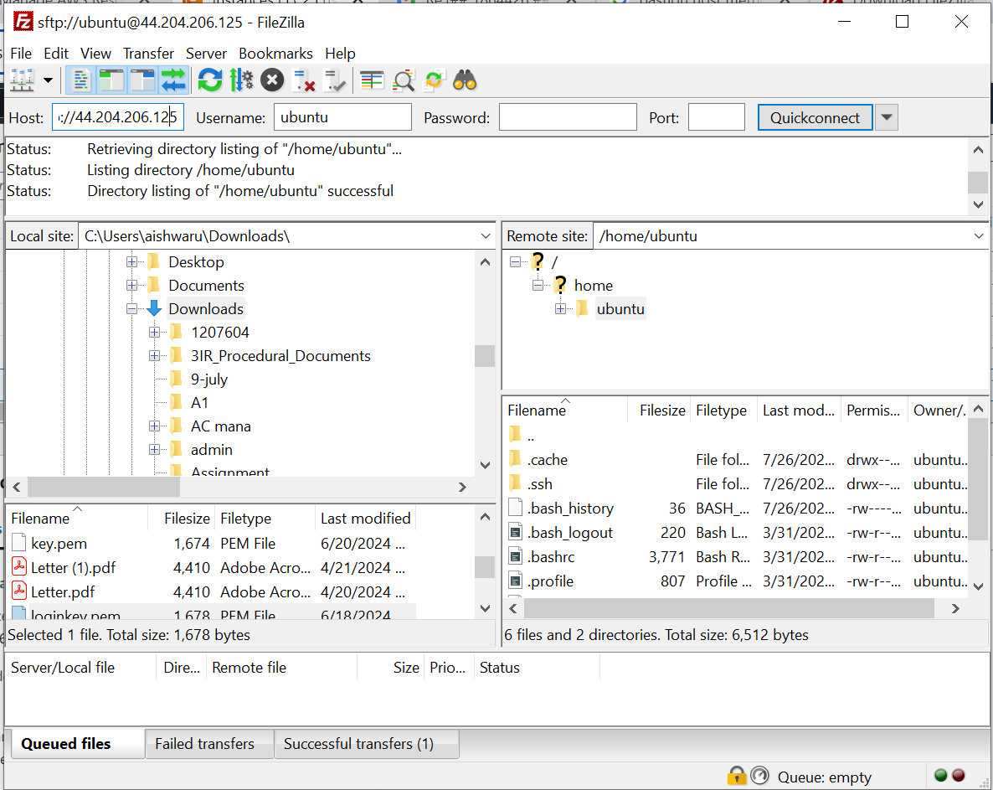

Now connect to the public instance

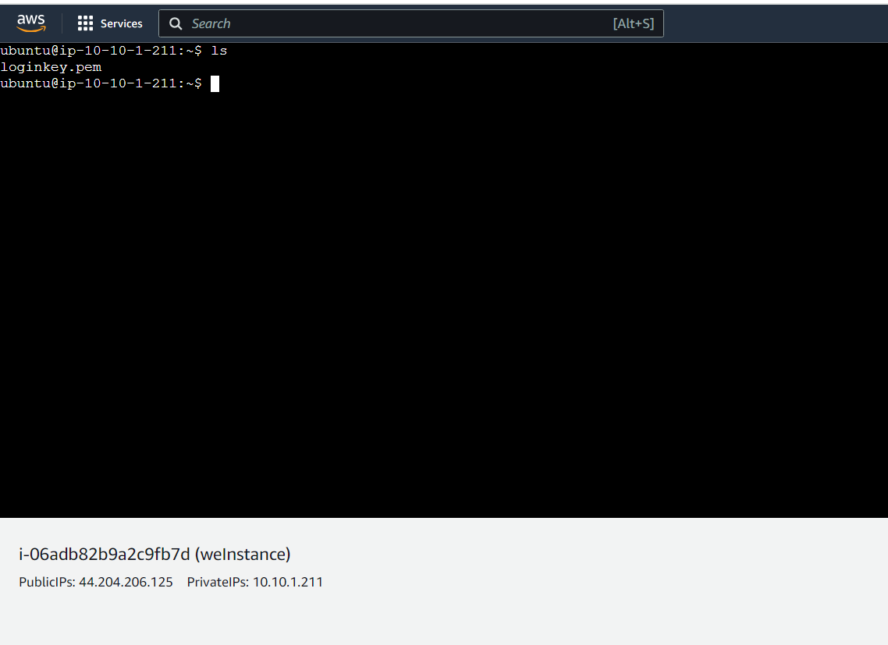

Take private IP of dbcache and using ssh cmd connect to private dbcache instance

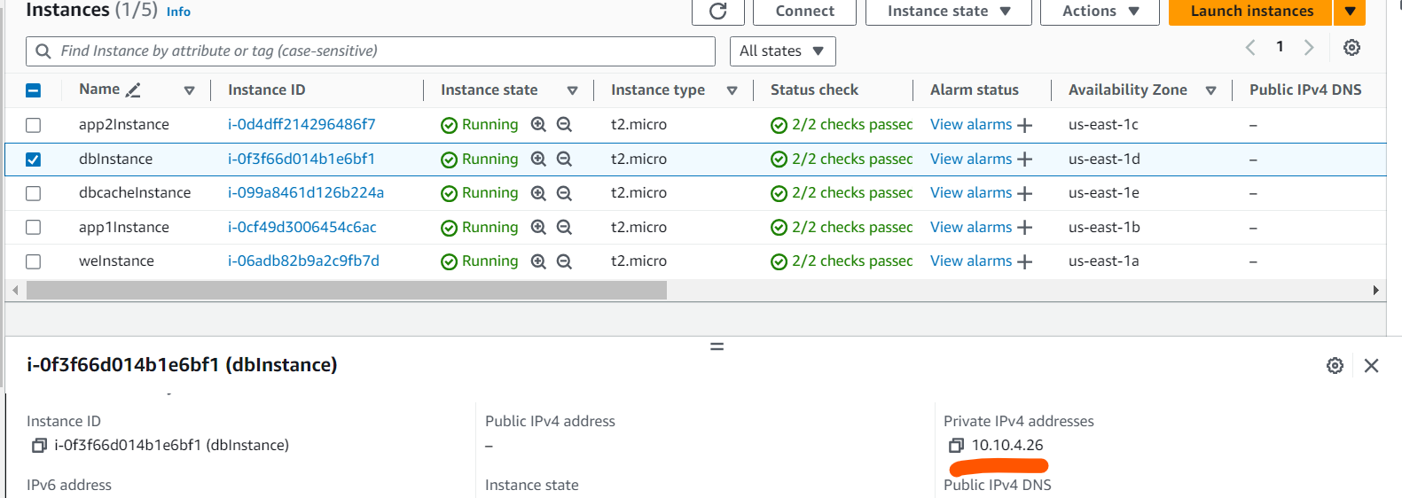

ssh -i /home/ubuntu/loginkey.pem [ubuntu@10.10.4.26](mailto:ubuntu@10.10.4.26)

sudo chmod 600 /home/ubuntu/loginkey.pem (to resolve unprotected error)

**successfully connected to the dbcache instance and able to ping to google.com**

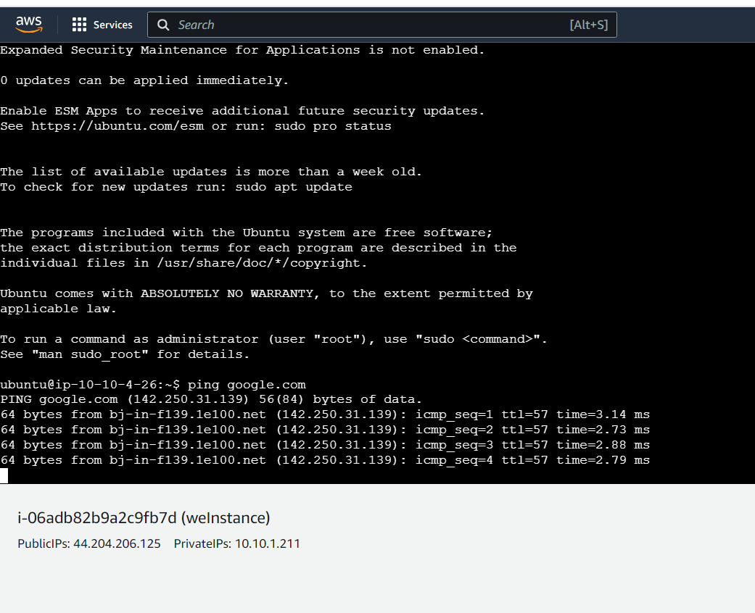

Now connect to app1 instance and ping google from web instance

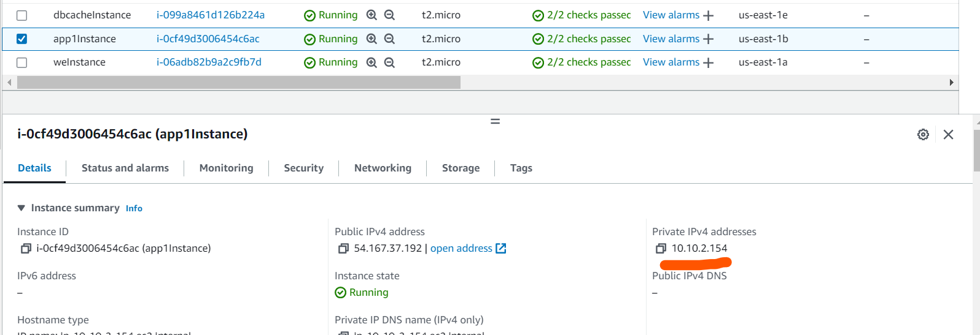

ssh -i /home/ubuntu/loginkey.pem [ubuntu@10.10.2.154](mailto:ubuntu@10.10.2.154)

sudo chmod 600 /home/ubuntu/loginkey.pem (to resolve unprotected error)

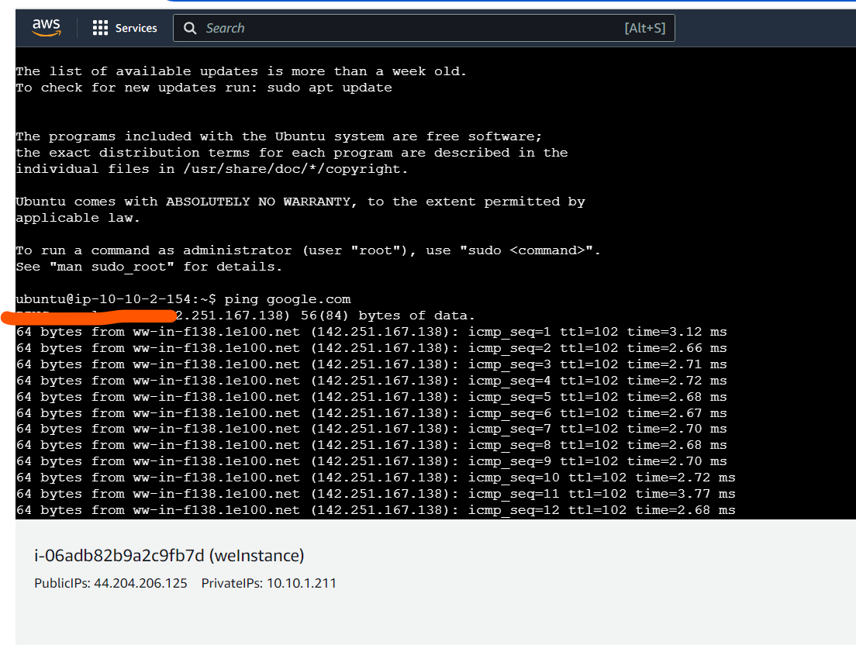

**Development Network:**

1. Design and build 2-tier architecture with two subnets named web and db

and launch instances in both subnets and name them as per the subnet

names.

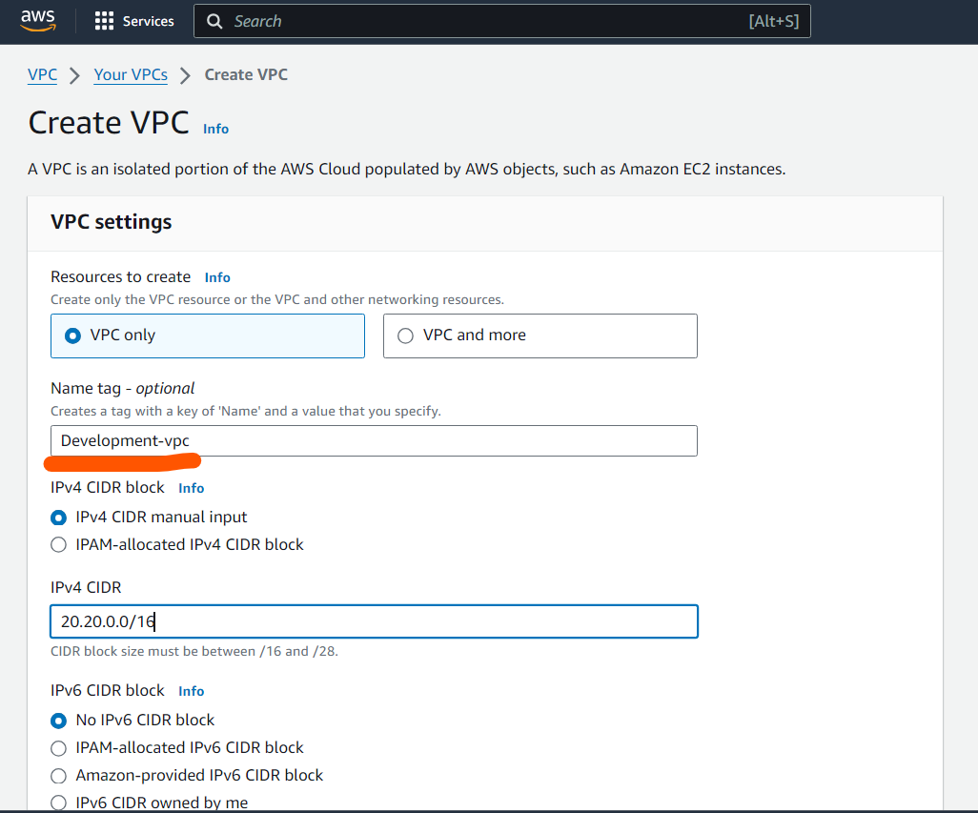

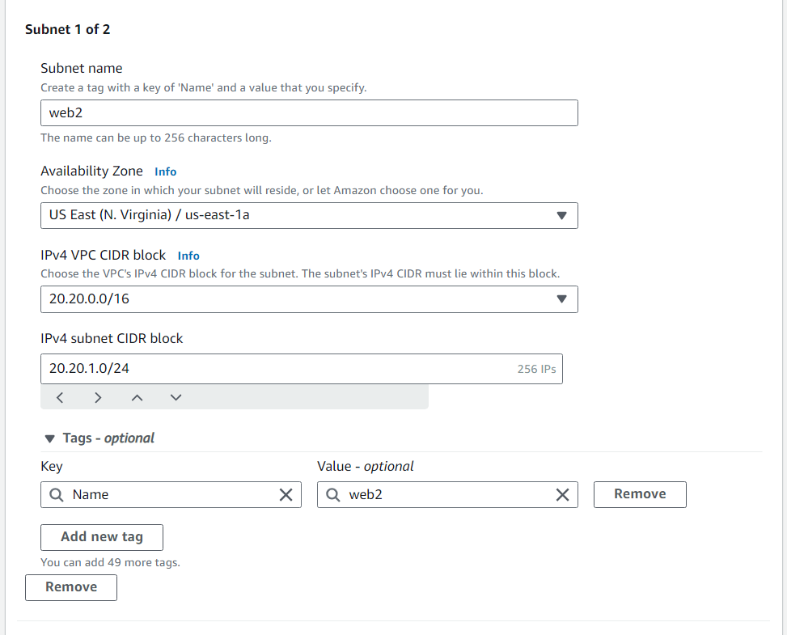

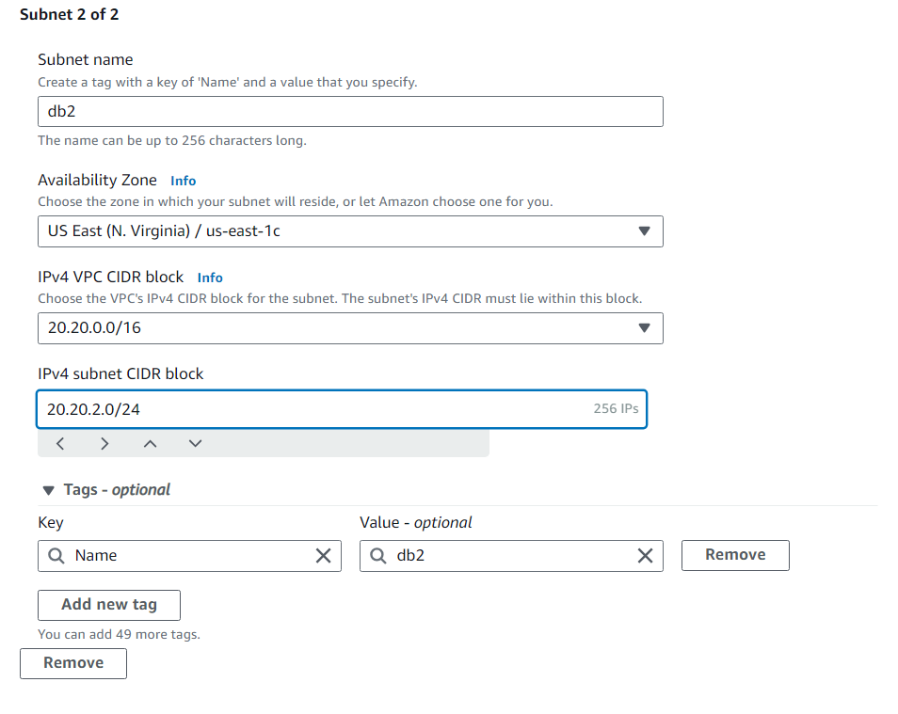

Create instance

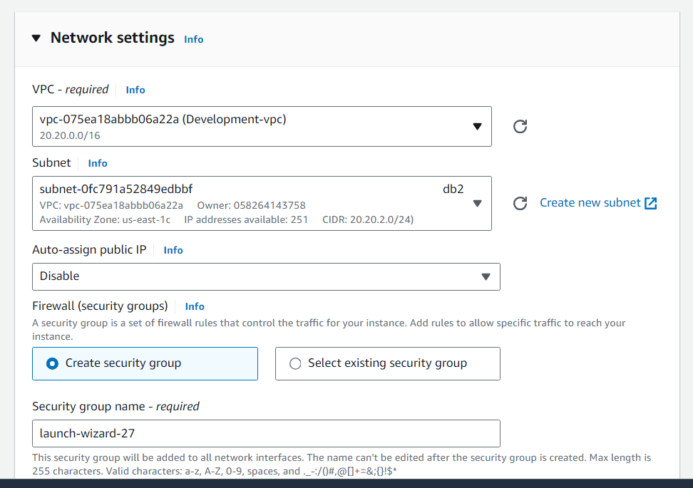

2. Make sure only the web subnet can send internet requests.

Create internet gateway attach to development VPC and edit route table

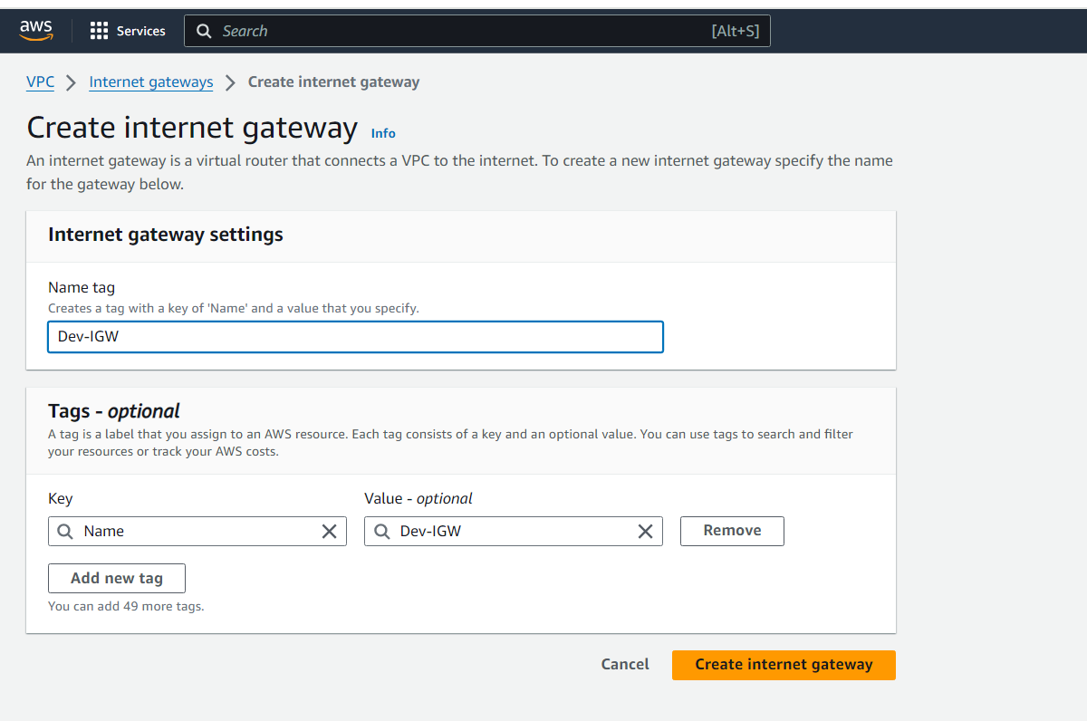

Attach to dev VPC

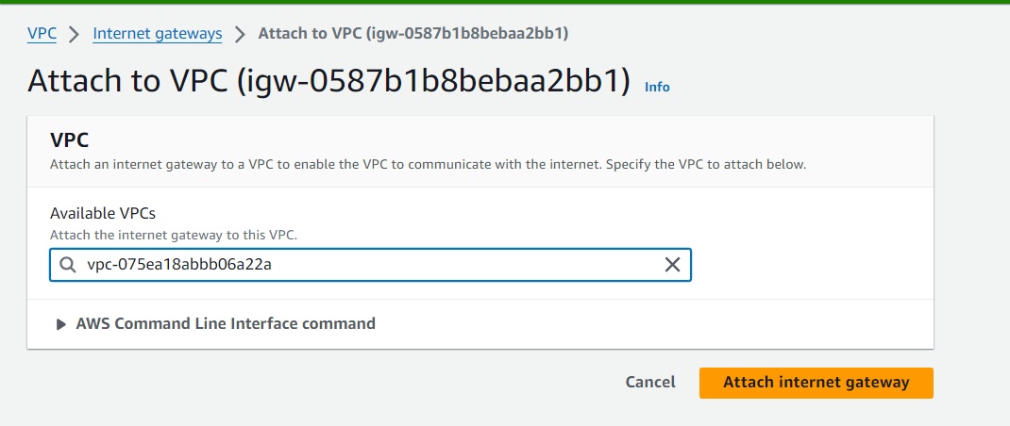

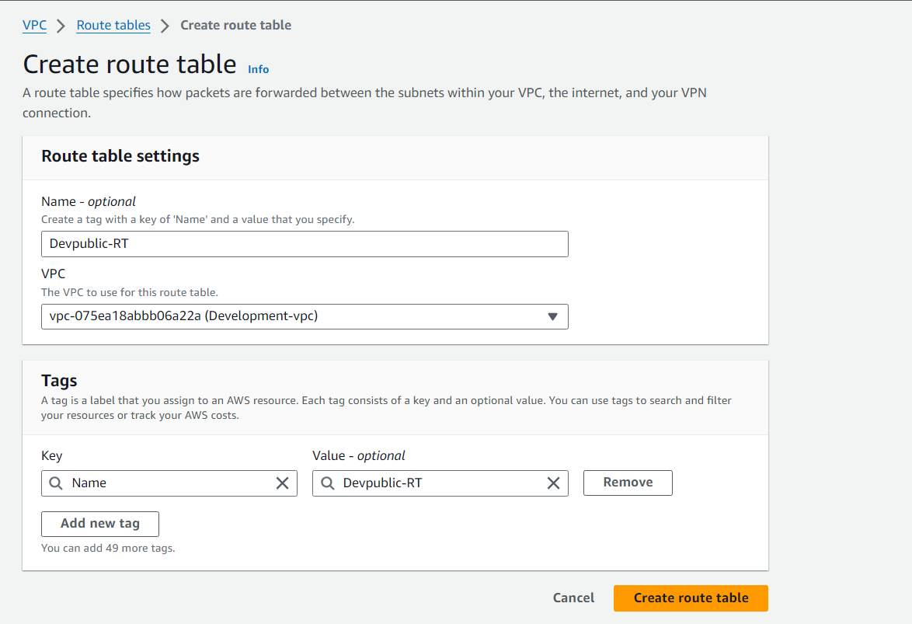

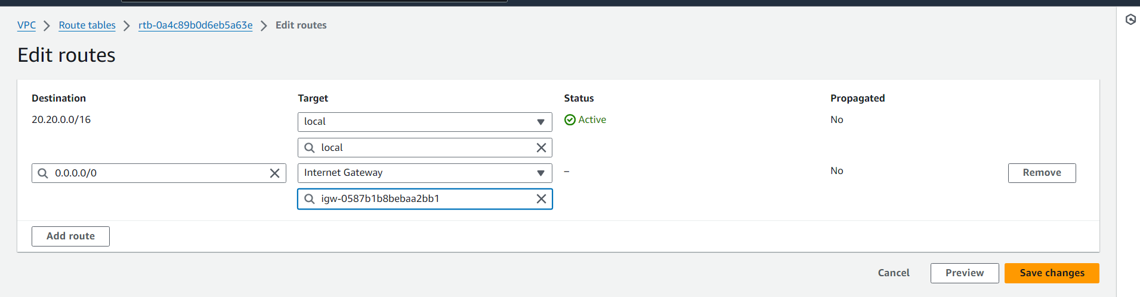

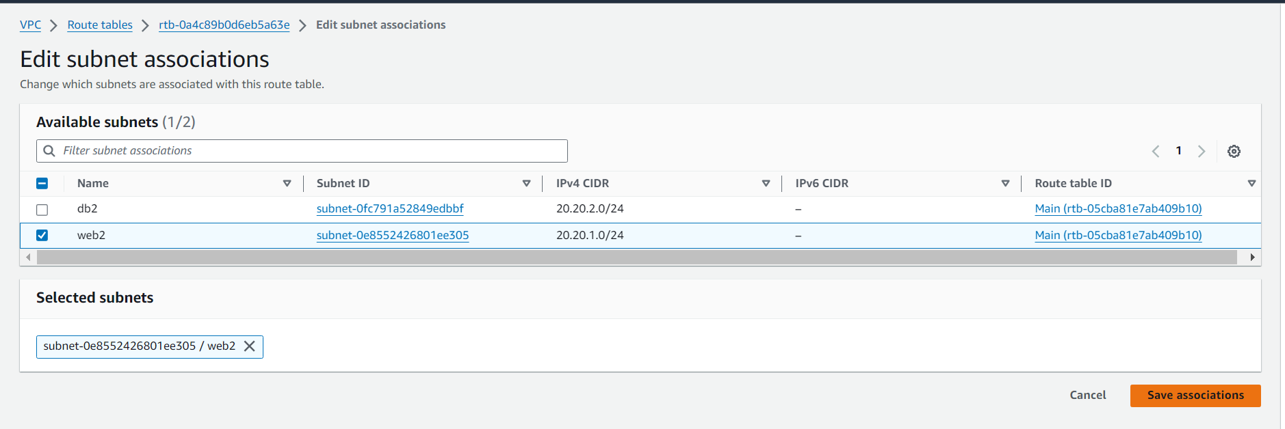

Create instance with below network setting

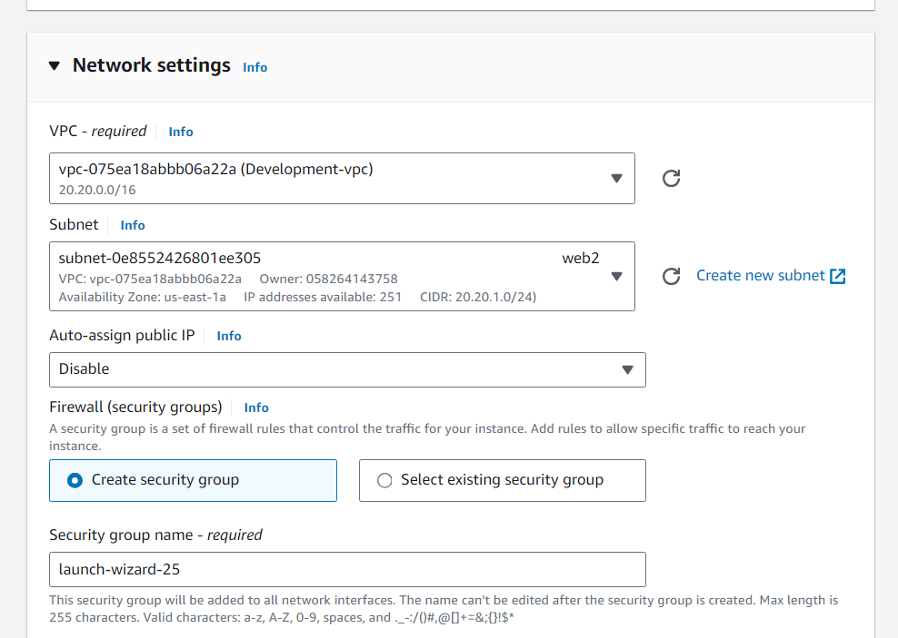

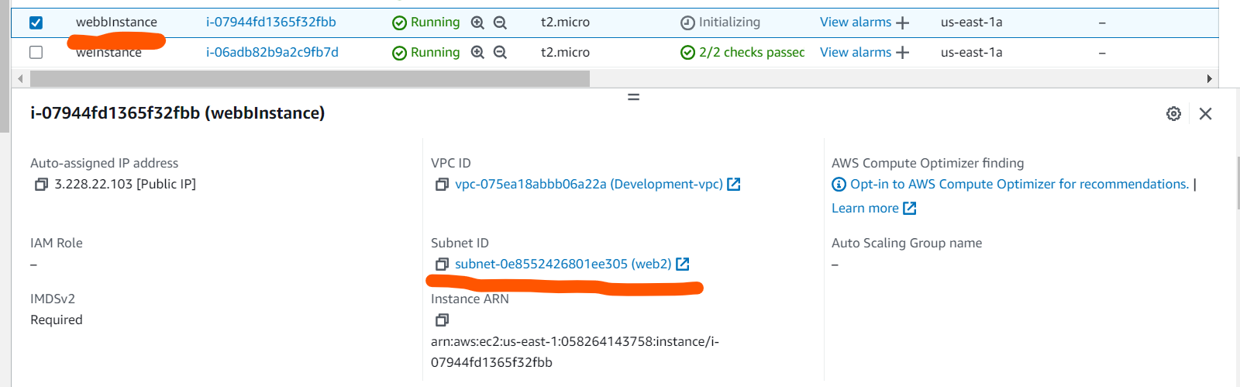

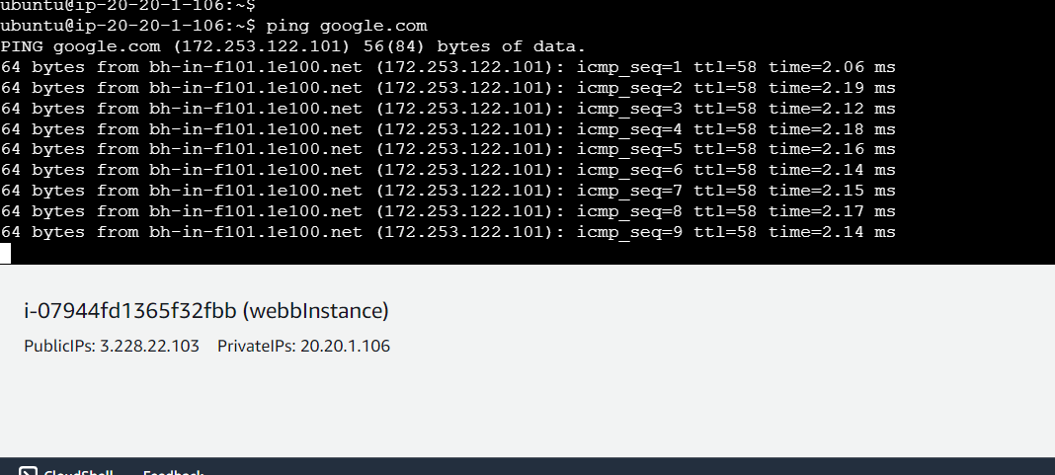

3. Create peering connection between production network and development

network.

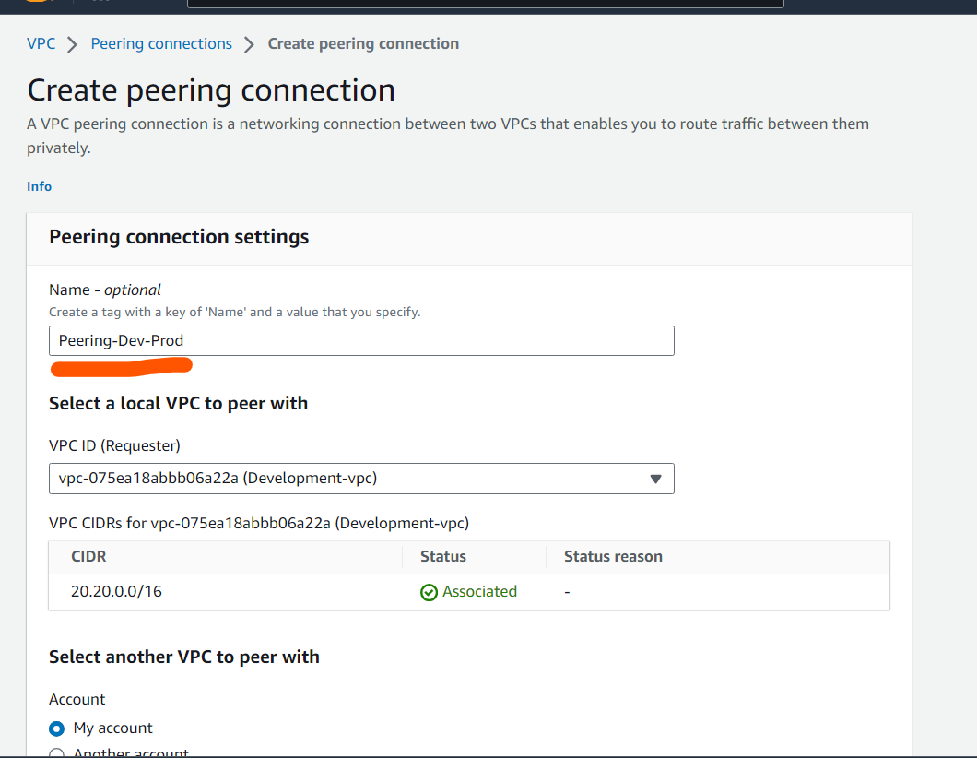

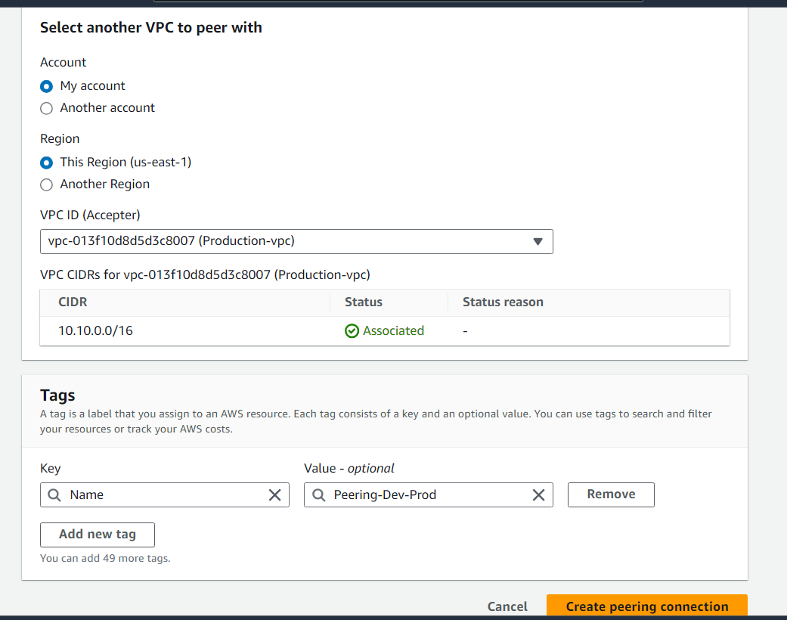

Accept the peering connection

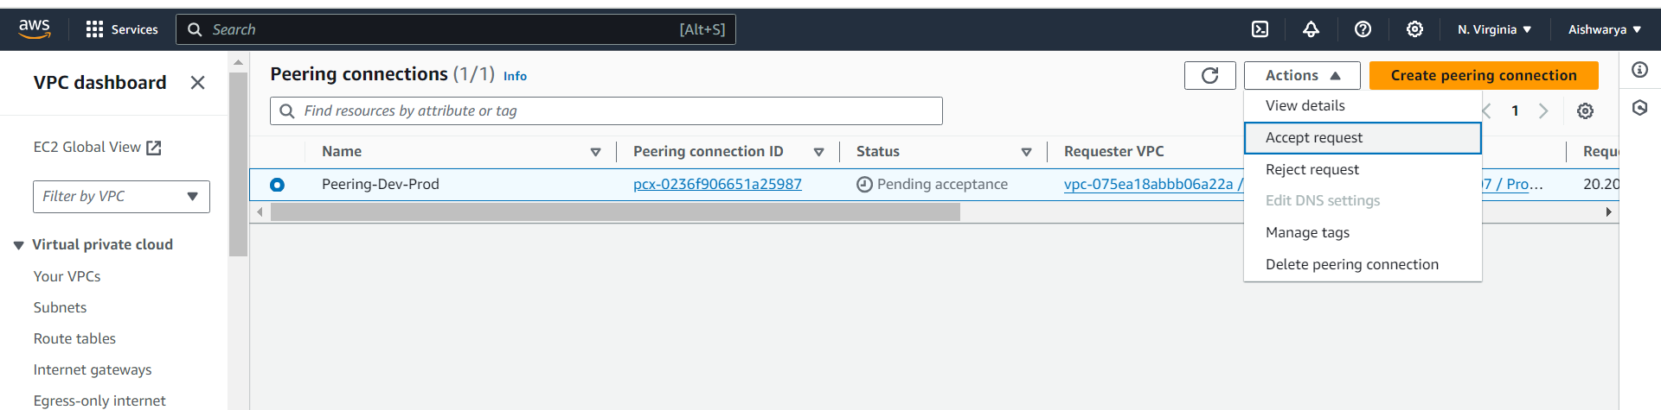

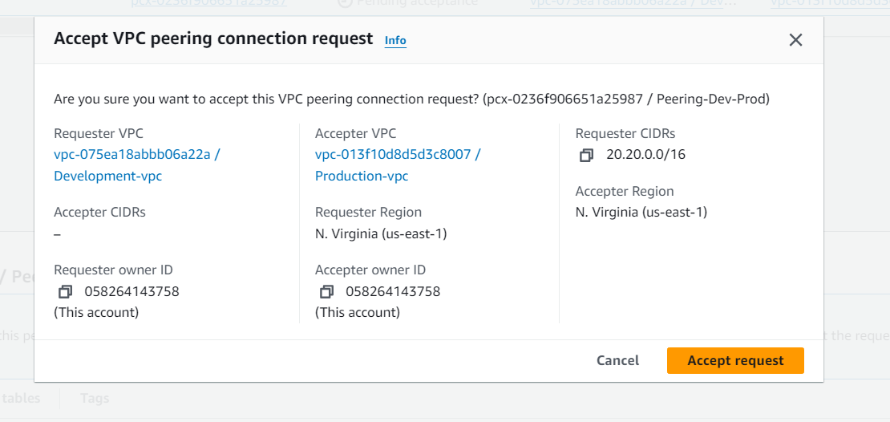

4. Setup connection between db subnets of both production network and

development network respectively

Create 2 Route Tables

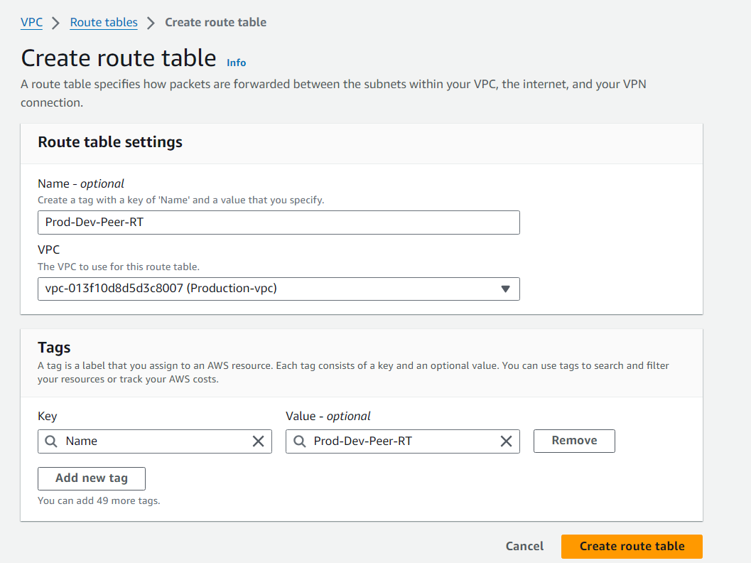

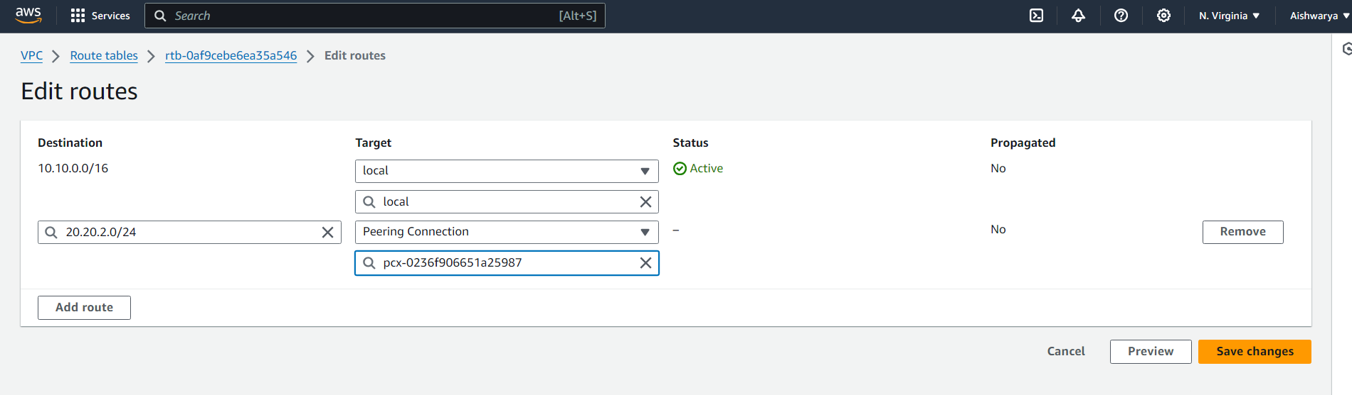

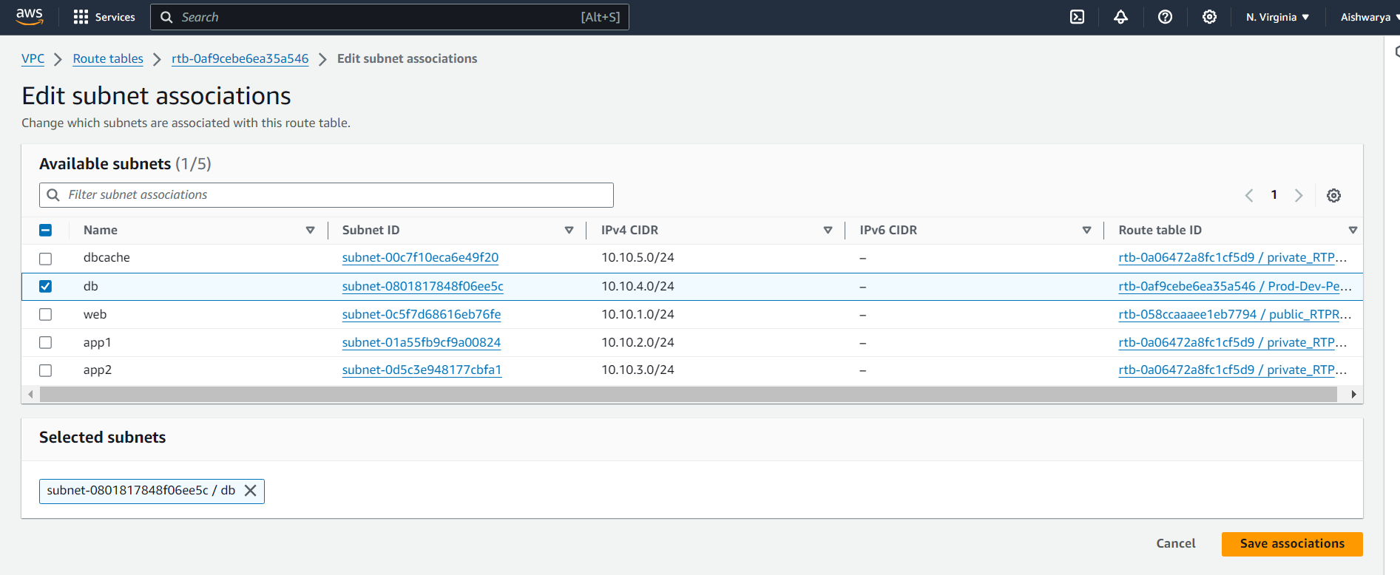

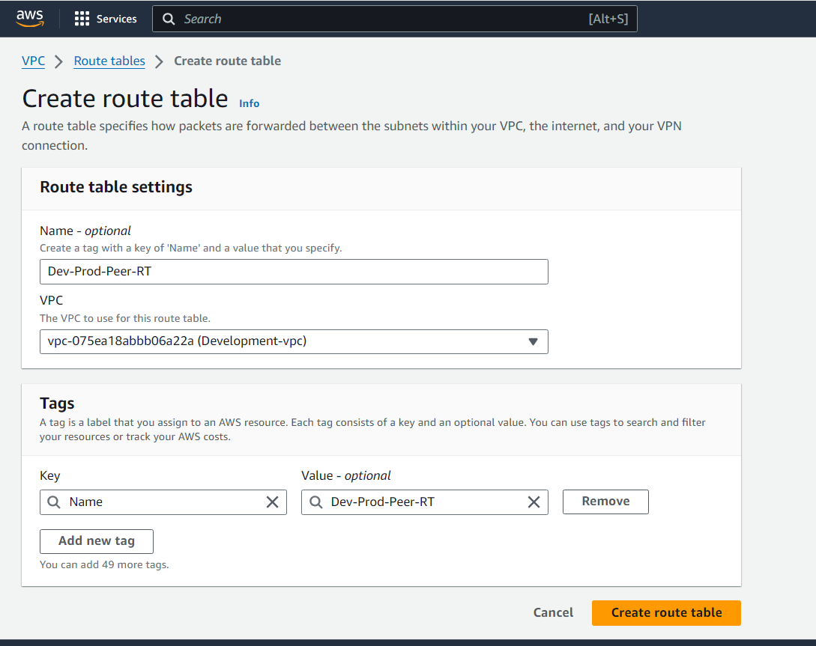

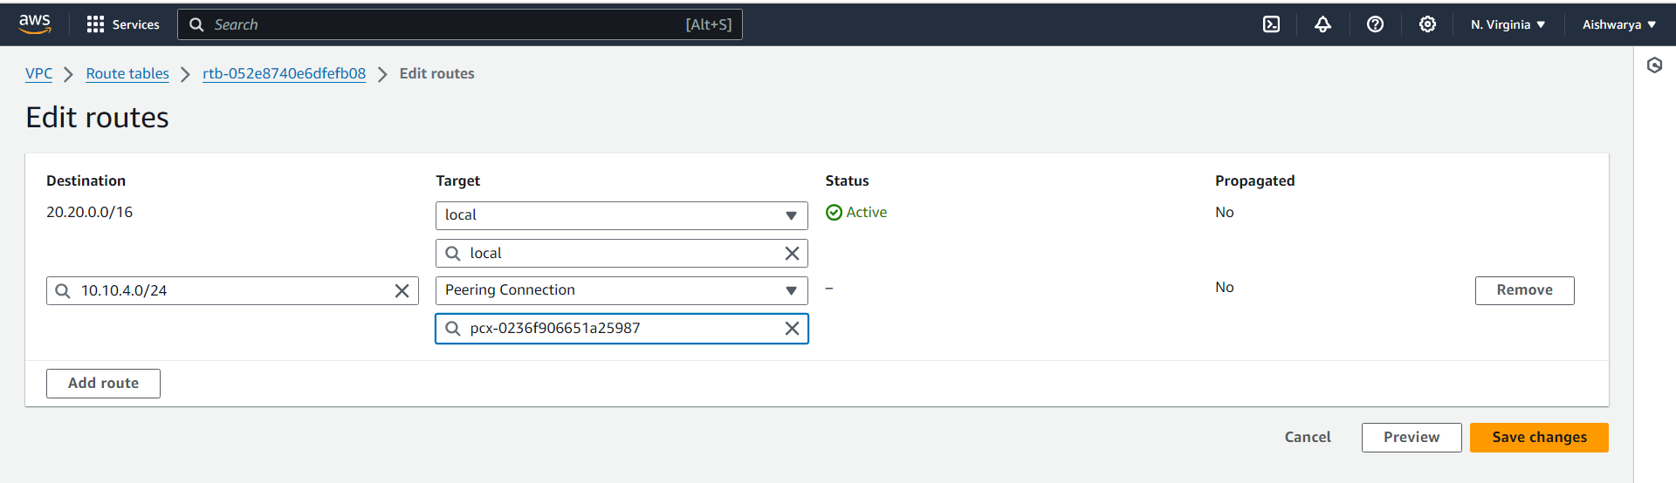

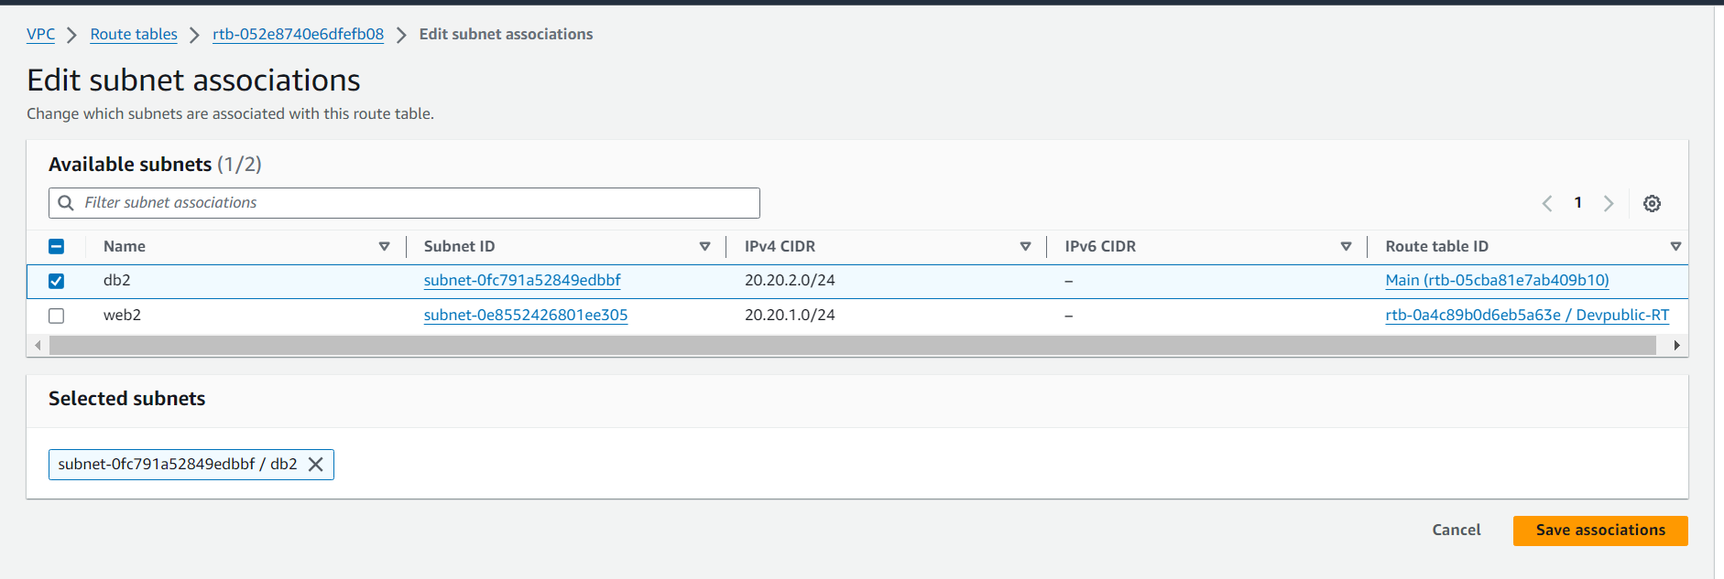

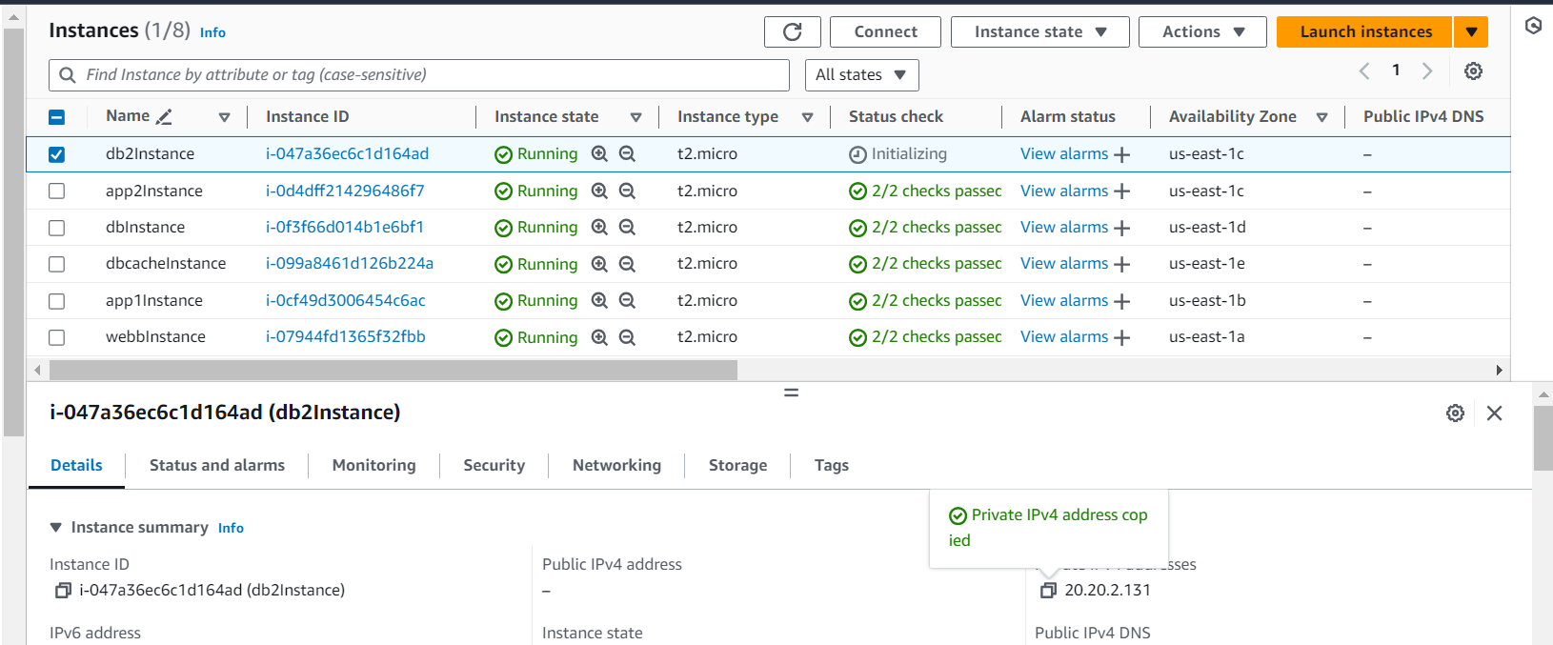

20.20.2.131

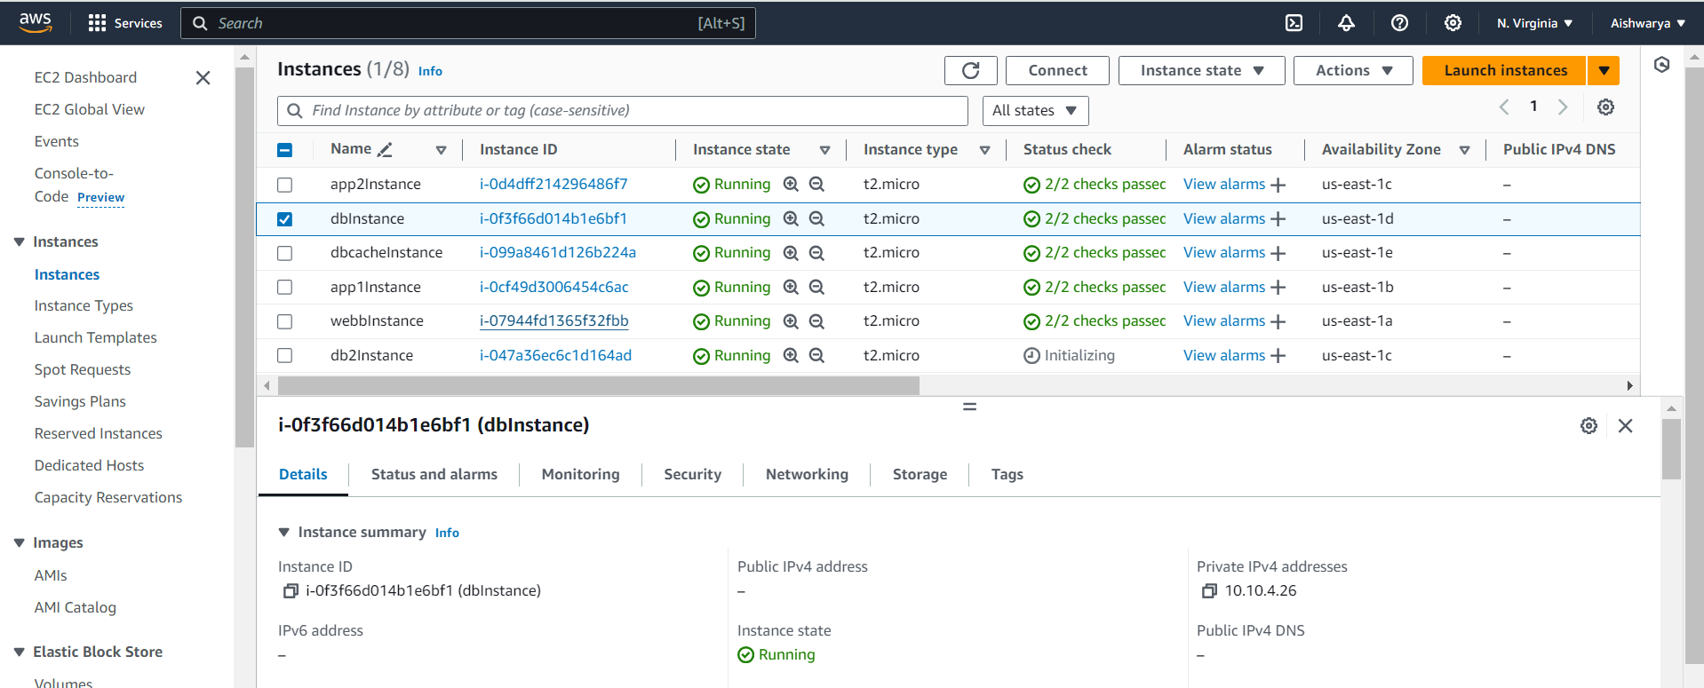

10.10.4.26

Connect to weInstance of production

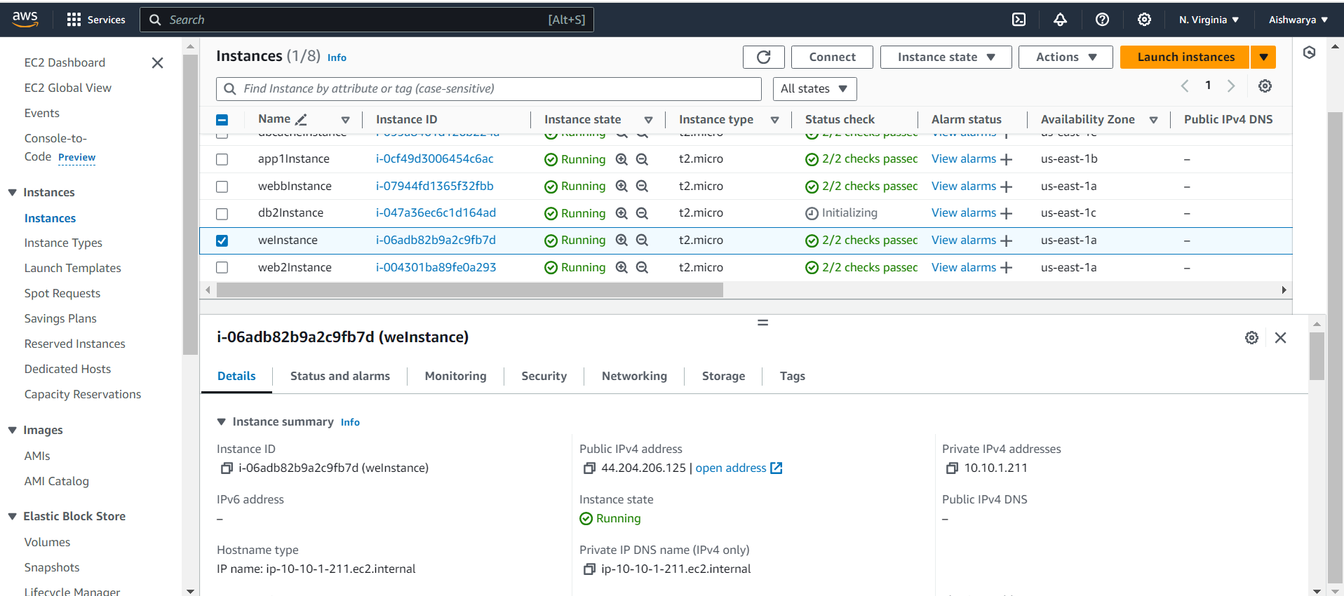

Now connected to dbInstance from WeInstance

ssh -i /home/ubuntu/loginkey.pem [ubuntu@10.10.4.26](mailto:ubuntu@10.10.4.26)

sudo chmod 600 /home/ubuntu/loginkey.pem (to resolve unprotected error)

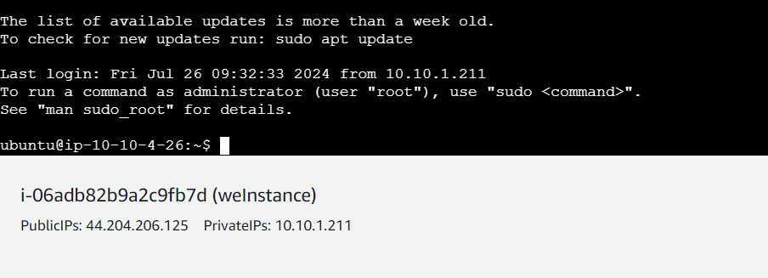

Copy login key from weInstance to DbInstance by using private IP of Dbinstance

scp -i /home/ubuntu/loginkey.pem /home/ubuntu/loginkey.pem ubuntu@**10.10.4.26**:/home/ubuntu/loginkey.pem

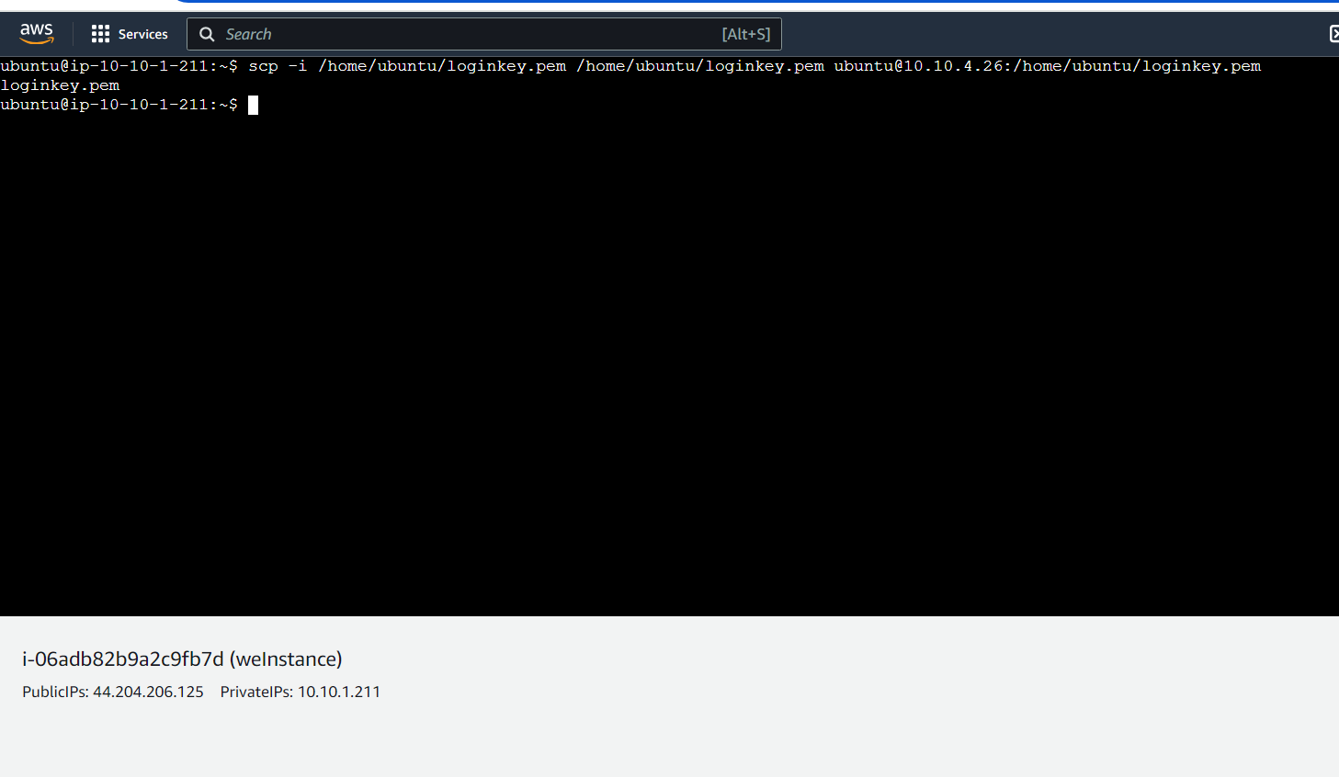

Now connect to dbIndstance

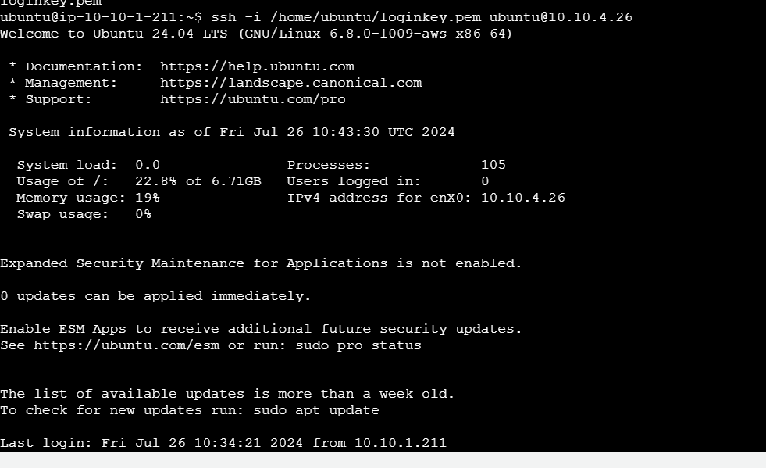

And key is present

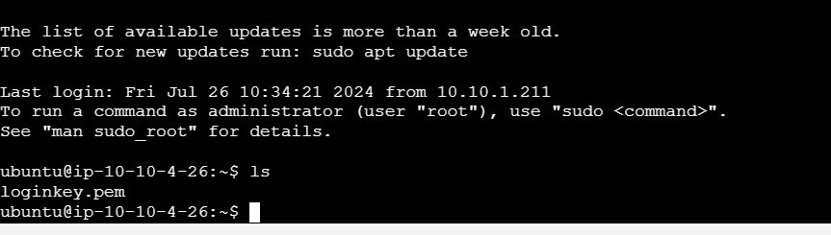



Now connect to db2Instance using private Ip 20.20.2.131

ssh -i /home/ubuntu/loginkey.pem [ubuntu@20.20.2.131](mailto:ubuntu@20.20.2.131)

sudo chmod 600 /home/ubuntu/loginkey.pem (to resolve unprotected error)

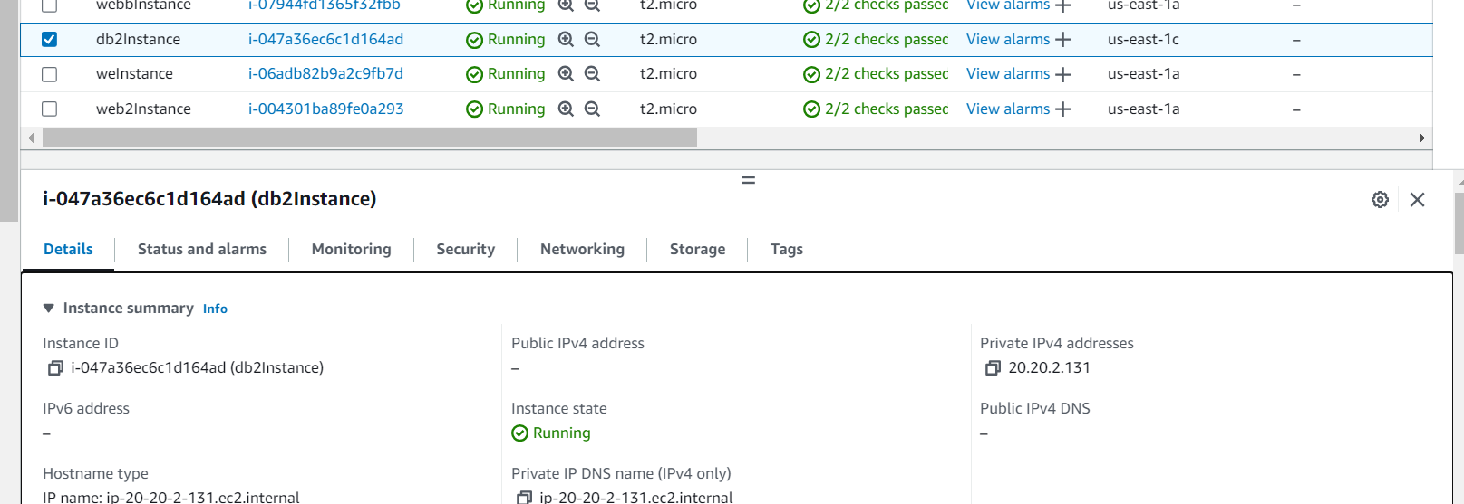

Successfully connected to db2Instance from dbInstance via WeInstance using key

